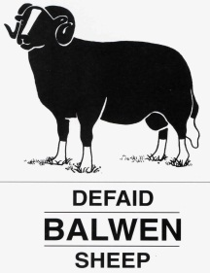
CYMDEITHAS DEFAID MYNYDD CYMREIG BALWEN
BALWEN WELSH MOUNTAIN SHEEP SOCIETY
SWFFRYD FARM HAFODYRYNYS CRUMLIN GWENT NP11 5HY
TELEPHONE 01495 247869
www.balwensheepsociety.com
NEWSLETTER July 2019

Hi All
Hope you are all well and enjoying the showing season so far.

After lots of discussion regarding future sales, due to circumstances beyond our control, Dai Lewis CYF will not be selling the Balwens at the sale in September. Nock Deighton have agreed to sell for us but the entry forms do NOT say this.
Please return your entry form and entry fee to me at the above address.

Inspection Dates for 2019

Saturday 3rd August - Bryncir Market, North Wales, start 1 pm BOOK IN WITH CHRIS LEWIS
Sunday 4th August - Manchester and the North, BOOK IN WITH CHRIS LEWIS

Wednesday August 7th – Llanybydder Market start 10.30am CPH 55/066/8561, BOOK IN WITH MAIR WILLIAMS

Sunday October 20th – Builth Wells Market, start 10am, book in with Anne
Cirencester area – contact Chris Lewis
South West, Contact Chris Lewis

Please pre – book at least 2 days before the inspections
Any other area please contact Chris Lewis (Field Officer), on
01600 780087, as soon as possible.

Mobile No. on the day for all inspections: Chris Lewis 07792232758

Important Note – Lambs MUST have EID tags in before they come to inspection or they WILL NOT be inspected.
All members are responsible for notifying EID Cymru of your movement

Please bring two completed movement licences, outward and inward, with accurate details of animals.
NO ANIMAL WILL BE INSPECTED UNLESS YOU BRING BOTH SIRE AND DAM NUMBERS WITH YOU – PLEASE REMEMBER YOUR TAGS
May I remind you to abide by the Society’s Bio-Security rules and that sheep having dirty feet will not be inspected.
May I also remind you to abide by the 6-day standstill on your holding unless you have a designated isolation unit approved by Defra.
PLEASE NOTE- NO ANIMALS WILL BE INSPECTED AT SALES IN THE FUTURE
Reminder for everyone – Inspections can be arranged at home but unfortunately there is a charge of 50p per mile to cover the cost.

AGM
The AGM was held on Sunday May 12th at the Llanelwedd Arms Hotel, Builth Wells.
Chairman, Mr Huw Williams welcomed everyone to the meeting and gave an overview of the last year’s events. Huw thanked all committee members, judges, inspectors and exhibitors, particularly young handlers for their commitment to the breed. The shows are our shop window and it is great that so many support the society.

Appointment of Officers
President, Mr Martin Groucott (Flock 234)
President Elect, Mr Chris Lewis (Flock 101)
Chairman, Mr Huw Williams (Flock 10)
Vice Chairman, Miss Gina Davies (Flock 289)
Secretary, Mrs Anne Groucott (Flock 234)
Field Officer, Mr Chris Lewis (Flock 101)
Treasurer, Mrs Mair Williams (Flock 11)
Auditor, Ms Jones.
Website Administrator, Miss Lowri Davies
Society Auctioneers, Dai Lewis
4 Committee Members to serve for three years, Mr Alun Williams (Flock 11), Mrs Elizabeth Eagles (Flock 218), Mr Geraint Jones (Flock 24), Mr Paul Wozencraft (Flock 38).
Balwen Club winners – 31 – Tomlinson, 64 – Mair Williams Glynglas, 80 – Peter Williams, 39 – Steve Newman, 47 – Orllwyn Flock
If you are not already involved in the Balwen Club, please join up. It costs just £5 a year and cash prizes are awarded twice a year. This money helps to boost the funds of the Society and hopefully help to avoid increases in costs. Don’t forget – ‘You’ve Got to Be in It to Win It’

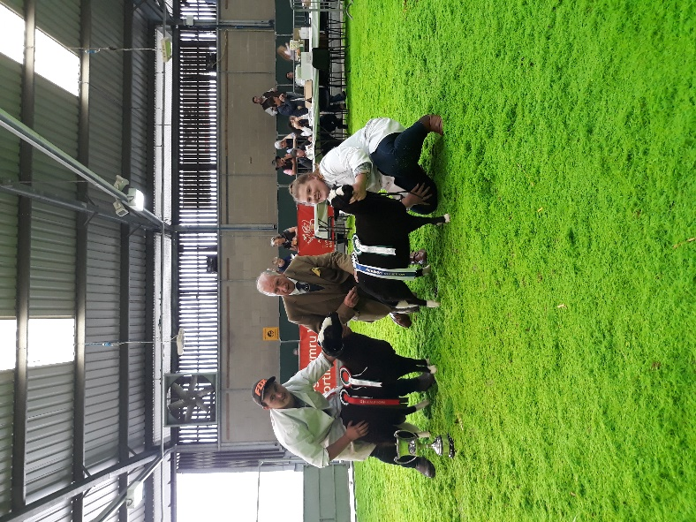
ROYAL WELSH SMALLHOLDERSThanks to judge, Mr Brian Eagles and all competitors. Congratulations to Meinir and Gary Howells, Sioned and Dafydd and to Chloe Edwards who were champion and reserve respectively.
Thanks to all who helped with the stand– Mrs Elizabeth Eagles for the floral display, Huw and Mair Williams for loaning an ewe and lamb and everyone who provided craft items to make our stand as attractive as it was. Thanks also to people who volunteered to take a turn to man the stand and to everyone who helped to set up the stand, particularly Sue and Graham Williams. Your help is very much appreciated.

Well done to Chloe who also won with her Blue Texel sheep

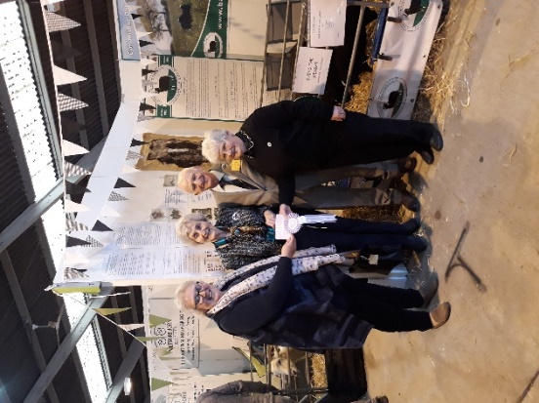
I am delighted to say our stand was runner up in the best sheep trade stand competition.

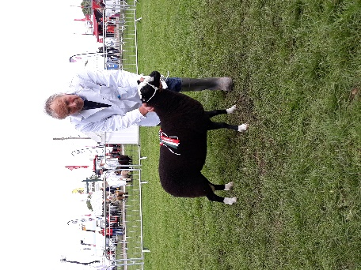

Royal Three Counties
RBST invited us to take some sheep for their stand at the show. There was quite a lot of interest in the breed so hopefully this will develop into some new members joining the Society. Unfortunately, due to lack of entries this year there was no dedicated Balwen class and we were put into the ‘Any other Hill’ classes. We were up against Derbyshire Gritstones but were lucky enough to win the section.

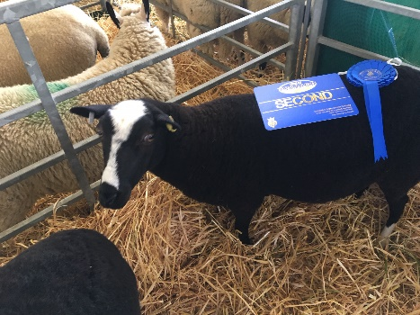
Great Yorkshire Show
Thanks to Debra Northing for taking her sheep to the show and promoting our breed at the Great Yorkshire. Deb was second in the ‘Any Other Hill and Heath class and took breed promotion items for the Rare Breed Stand where again, there was quite a lot of interest. Thank you to Aled Groucott for transporting the promotion items for us.

ROYAL WELSH SHOW JULY 22nd – 25th 2019
Almost here!!
One lucky Balwen exhibitor will have the pleasure of winning the ‘Queen’s Cup’ this year.
The Prince of Wales is also attending and who knows, he may present the cup?
Our judge this year is Mr Geraint Jones Lewis (Flock 70) and judging will be on Monday at 12 noon. May I remind you that all sheep, (except lambs), presented at shows and sales after 30th June, need to have been shorn in that current year.
Could I please remind trophy winners from 2018 to return the trophy (shining and sparkling), to me before the start of the Balwen section judging – THANKS

Please note Royal Welsh Agricultural Society – Rule 21
Exhibitors in all sections (except goats) are not permitted to enter an animal in any class, which is to be judged by a person who has had a financial or other interest in the animal, or which has stood in his or her yard. The onus of complying with this regulation rests entirely on the exhibitor.

Date of Sale for 2018 – Monday September 23rd. Please try to support this sale if you can, purchasers come from all over the country!

Pencefn and Alun and Mair Williams Trophies
These trophies will be presented to members gaining the most points at shows during 2019 and the animal gaining the most points. Would those of you entering, please send your results to me by 23rd September 2019. Points can only be counted if the show has a Balwen class and a Balwen judge. These competitions are open to all paid up members – You gain 3 points for 1st place, 2 points for 2nd place and 1 point for 3rd place. As a trial for this year we will award double points at the Royal Welsh, hopefully, to encourage more entries in both competitions.
Presentations will be made at the Annual Dinner which is booked for Saturday December 7th 2019 at the Greyhound Hotel, Builth Wells.

DON’T FORGET ------Royal Welsh Get-Together will be on Wednesday evening in the sheep ring after the competitions have finished – we have a back-up plan if it is raining, (not sure what it is yet but it isn’t going to rain!) If you would like to join us please provide your own drinks, nibbles and chairs (if you wish to sit down).
We have had some lovely evenings so far, so please join us. It is a great opportunity for new members to get more involved with the Society.
Please let me know if you intend to join us so we know numbers for catering - Everyone welcome!!! – This is for exhibitors and Balwen members, family and friends visiting the Royal Welsh.
If you are able, would you please bring a raffle prize as this is another opportunity to raise much needed funds for the Society?

Congratulations to Roger Davies who is President Elect of the Welsh Pony and Cob Society

Congratulations to Jack Jones who is about to represent Wales in karate.

Well done to everyone with their exam results and achievements so far, this year, don’t forget to let me know about them so we can all celebrate your success.

Don’t forget to send items in for inclusion on the website.

Anyone wishing to pay their membership by direct debit can do so using the following reference:
Name of person or organisation you are paying – Balwen Welsh Mount
Payment reference – Your own Balwen flock name or number
Sort code – 538107 Account Number – 08134898
Your bank will be able to set up the direct debit with this information.

Due to the recent increase in postage costs you will receive all correspondence, including AGM notification by email if you have given an email address.
If you have an email address but have not told me, or if you have changed it, would you please let me know it asap as email information can reach you a lot quicker than post and save money.

Hope to see lots of you at the Royal Welsh Show
All the best
Anne

